 Pangani Basin Water Board 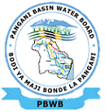
Hydrological Bulletin December 2025
2025

RAINFALL TRENDS
Generally, rainfall in the basin is bimodal. Rainfalls are categorized in two periods; long rains occurring in March-June and short rains October –December. Rainfall patterns are largely controlled by altitude; the highlands receive more rains about 1000-2000mm per annum while the lowlands receive rains between 500-600mm per annum.
The data collected from 31 representative rainfall and met stations in the basin have been categorized using the agreed criteria of percentage Mean Annual Precipitation (%MAP). These categorization as follows;
- Less than 75% regarded as Dry,
- Ranging 75-125% regarded as Average and
- Greater than 125% regarded as Wet.
General distribution of rains in the basin were not even although most of the areas in the basin ranged from dry to average except in few stations (6 stations) were wet. The maximum rainfall in December 2025 was 910mm, minimum rainfall was 0mm and average rainfall 66.52mm

RIVER FLOWS
The Pangani Basin has two main headwater rivers feeding the large reservoir Nyumba ya Mungu Reservoir, the Kikuletwa River and Ruvu River. The Ruvu supplying water to Nyumba ya Mungu effectively forms part of the upstream of the main Pangani River (after the dam). The source of (this) Ruvu in the Pangani system is from Lake Jipe and surrounding catchments (including areas influenced by northern slopes of mountains like Mount Kilimanjaro). Ruvu via Lake Jipe and its catchment is critical source for the Pangani Basin’s water supply, hydropower, irrigation and downstream flow. The average flow of Ruvu (as feeding Nyumba ya Mungu) is this month was 4.56 m3/s. The upstream tributary Kikuletwa (which helps feed the Pangani via Nyumba ya Mungu) has average flow of 11.502 m³/s. Long-term (historical) discharge for Pangani at Korogwe station shows mean monthly flows roughly ranging from 22 to 39 m³/s depending on month.

WATER LEVEL IN DAMS
Nyumba ya Mungu
Water level in the Nyumba ya Mungu dam is affected by rainfall and runoff situation in upstream catchments (Kikuletwa and Ruvu). One can even tell water resources situation in the Basin by just analysing flows at Nyumba ya Mungu Dam. Water level in the week no. 45 (December 2025) is 684.82 metre above sea level. This level is above minimum water level for hydropower generation (683.35 masl) by 1.47m. In year 2024 for the same week, water level was 687.65 masl. This conclude that year 2024/2025 is dry to average in terms of water availability.
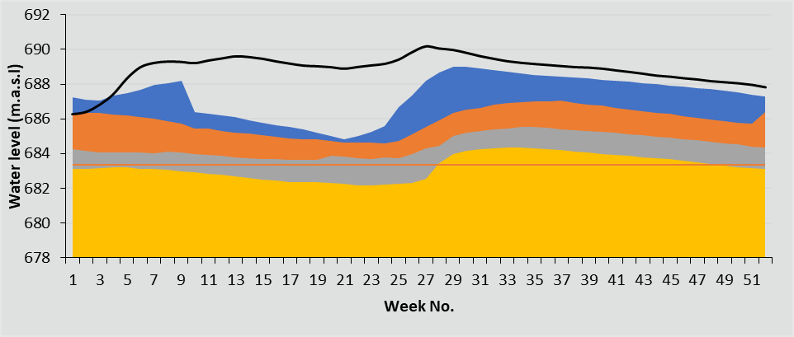

CONCLUSION
Similar to other months of this hydrological year, the water resources outlook in this basin have proven to be health even in this month of December. As we are heading to rainfall season, Water levels of the Nyumba ya Mungu Dam are expected to be higher than their monthly averages.

